Aphrodite’s Harvest Website UX Audit and Improvement Report

1. Review Homepage Layout

Advantage
The first screen on the homepage can quickly convey the business content. The main title "Adelaide Beekeeping Training and Support" together with the subtext enables new visitors to understand within a short time that this is a website providing beekeeping training and support services; meanwhile, the CTA on the first screen directly leads to the courses and support services, with a clear information path.
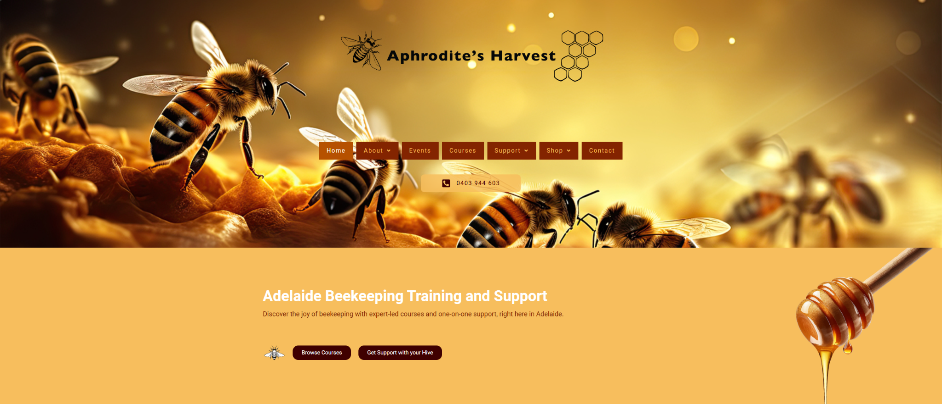
The homepage continues to present the value proposition module "Why Choose Aphrodite's Harvest?" after the first screen, and further explains the brand positioning through images and descriptive text. This helps to establish a sense of professionalism.

Disadvantaged
The visual competition in the Hero area is relatively intense
The top area of the homepage simultaneously features multiple strong visual elements such as a large background image, brand name, decorative honeycomb graphics, navigation bar, and phone button. The result is not that the content is unclear, but rather that the visual focus is not concentrated enough. Users can recognize the brand at first glance, but they may not be able to immediately focus their attention on the most important main title and main CTA.

The layout balance of the second screen is average
On the left side of the main content area on the homepage is the main content and buttons, while on the right is a large honey-dripping decorative image. The decorative elements are quite strong, which can easily cause the page's center of gravity to shift to the right, making the main content area seem relatively light.
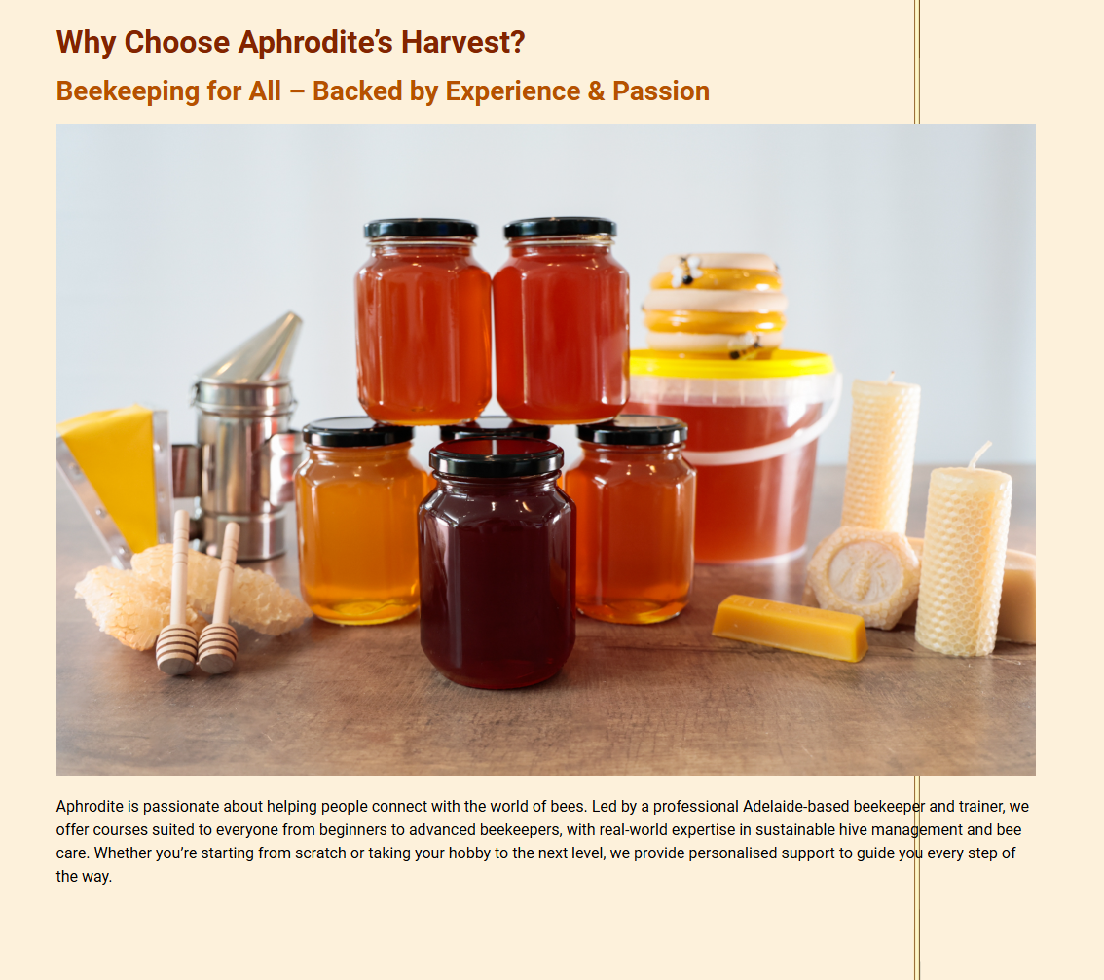
Moreover, when the page is not viewed in full screen, the honey-dripping decorative image may overlap with the main content, affecting the browsing experience.

2. Analyse Navigation Flow

Advantage
The website's information architecture foundation is complete. The main navigation covers the content that users are most likely to look for: brand introduction, events, courses, support, store, and contact pages. There are secondary navigation items under About, Support, and Shop, which indicates that the website has a sense of structure in functional classification.
From a process perspective, there are clear entry points from the homepage to courses, from the homepage to support services, and from the event page to support or course pages. The Events page also continues to offer "Get Support" and "Browse Courses" after the event content, which helps guide users from browsing information to further consultation or purchase.

Disadvantaged
The size and rhythm of the navigation bar buttons are inconsistent
From the actual interface, due to the different lengths of text for various menu items, the widths of the buttons vary significantly. However, as a whole, it does not form a deliberately designed sense of unity, so the header appears slightly loose and the scanning efficiency also decreases.

The sticky header behaves unstably after scrolling
After the page is scrolled, the top menu and the phone button overlap, indicating that there are issues with the layout, spacing, or layering in the sticky state. Moreover, the buttons that are below after scrolling cannot be clicked. This will directly affect the readability of the navigation and the accuracy of clicking.

The positioning of the phone button in the navigation system is ambiguous
It is both like a part of the navigation and like an action button. For users, this is not a serious process obstacle, but at the UI level, it weakens the sense of order in the top area.

3. Identify Usability Issues

Excessive recurrence of contact zones
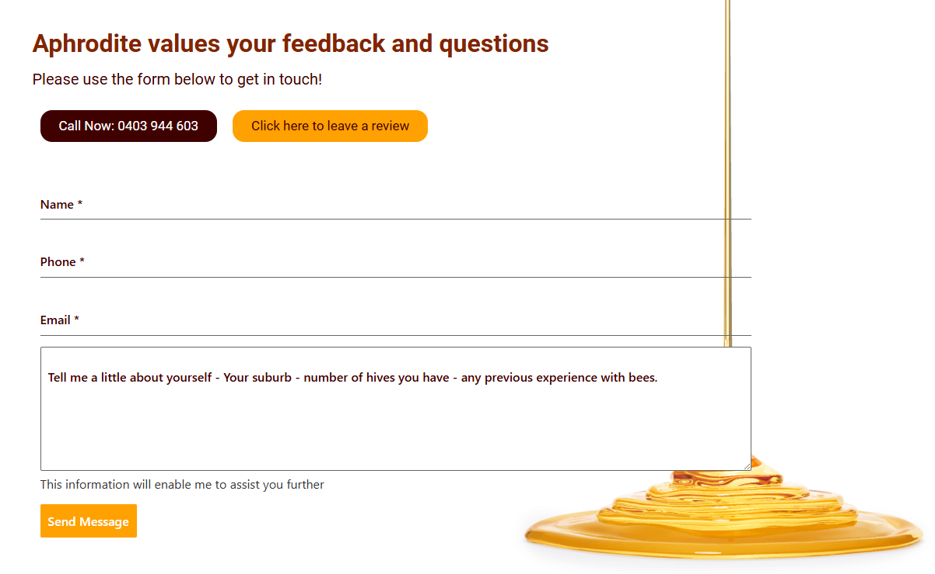
The pages such as the Home page, Events, Testimonials, and Courses all repeatedly feature a set of similar structures like "Call Now / leave a review / contact form / View Courses / Bee Keeping Support". In the web page text, it can be seen that the Home page, Testimonials, Events, and Courses all contain "Aphrodite values your feedback and questions", a phone button, form fields, and bottom course/support links. This reduces the uniqueness and focus of each page. After users enter different pages, they may easily feel that the latter part of the pages are repetitive.

CTA hierarchy lacks adequate definition
On the same page, multiple actions often appear simultaneously: browsing courses, getting support, making a call, leaving a comment, and filling out a form. All these actions are important, but if the visual emphasis is too similar, users will not be able to quickly determine "what is most recommended for me on the current page".

A slight path mixture is present on the Courses page
The "Courses" page states on one hand, "please complete the form below to register your interest," while on the other hand, it directly lists course prices, "Add to cart" and "Select options." This means that the page simultaneously serves two logical functions: "registering interest" and "product purchase." This may cause some users to hesitate in their decision-making process, unsure whether they should register first or place an order first.

Some copywriting elements exhibit moderate consistency
The footer and the bottom buttons of the page have the phrase "Bee Keeping Support", while the main text at the top mostly uses "Beekeeping". Such naming details can slightly affect the overall professional impression. Similar expressions have appeared at the bottom of the homepage, Events, Courses, and Testimonials pages.

4. Check Mobile Responsiveness

Page/Section | Mobile Issue | User Impact | Severity | Recommendation
Homepage hero | The mobile hero feels visually crowded, with branding, menu, phone bar, heading and CTA all competing for attention | Reduces clarity and weakens the first impression on small screens | Medium | Simplify the hero hierarchy and reduce non-essential visual competition
Homepage layout | The decorative honey-drip graphic remains too dominant on mobile  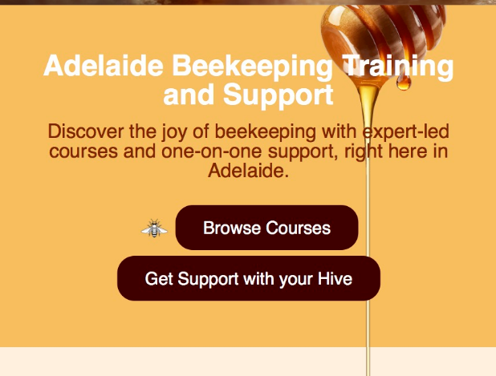 | Distracts from the main content and makes the layout feel visually split | High | Hide, scale down, or reposition decorative graphics on smaller screens
Mobile navigation | The expanded menu is complete but very long and dense  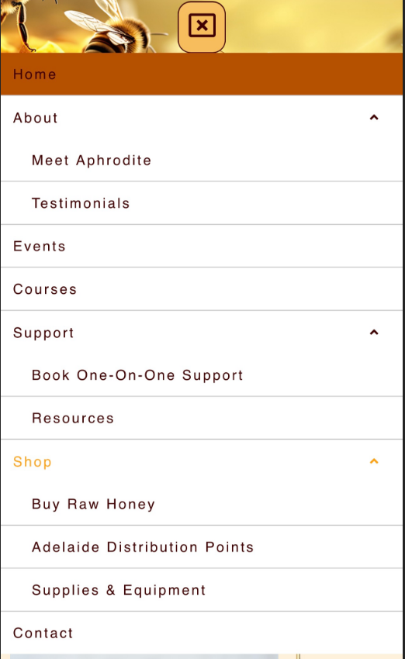 | Increases scanning effort and slows down navigation on mobile | High | Prioritise key links first and reduce the visual weight of secondary items
CTA strategy | Multiple CTA buttons appear repeatedly throughout the page | Makes it harder for users to identify the primary next action | Medium | Limit each section to one main CTA and reduce repeated action blocks
Footer | The footer uses a visually busy background with low text contrast  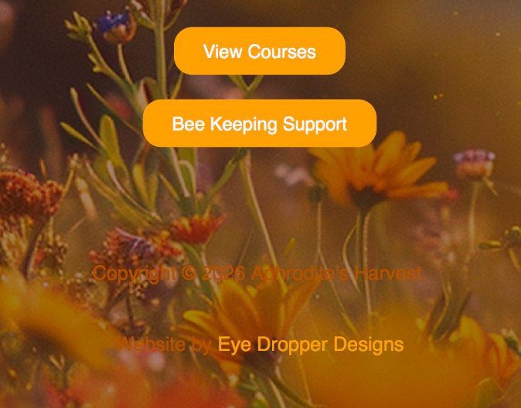 | Reduces readability of copyright and supporting information | Medium | Use a simpler footer background or stronger text contrast on mobile
Body content | Paragraphs remain relatively long for small-screen reading  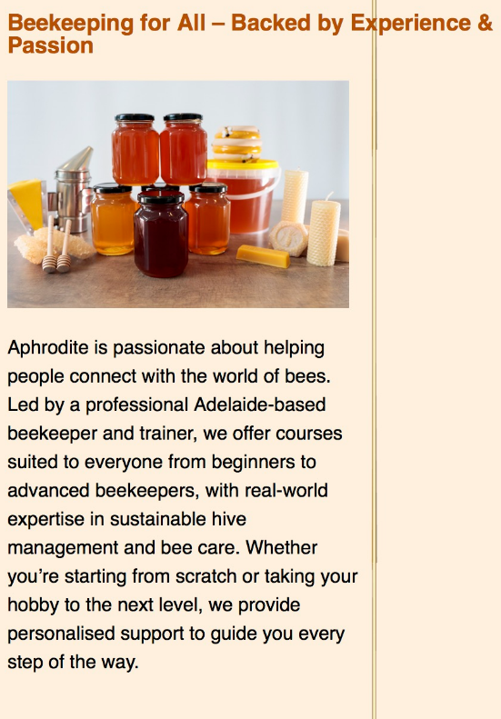 | Makes content harder to scan quickly on mobile | Low | Break long text into shorter paragraphs or sub-sections

5. Document UX Findings

Sub-task | Finding | Impact | Severity | Recommendation
Homepage layout | Hero area contains too many competing visual elements | Weakens focus on the main message and CTA | Medium | Simplify the hero composition and prioritise heading + primary actions
Navigation flow | Top navigation buttons are inconsistent in width and spacing | Makes the header feel less polished and harder to scan | High | Standardise nav button height, width logic, and spacing
Navigation flow | Sticky header overlaps when scrolling | Reduces readability and may affect click accuracy | High | Redesign sticky header layout and separate the phone CTA from the nav group
Usability issues | Repeated contact form and CTA sections appear across many pages | Creates redundancy and reduces page distinctiveness | Medium | Keep one primary CTA per page and avoid repeating the full form everywhere
Usability issues | Courses page mixes enquiry language with direct purchase actions | May create hesitation about the intended next step | Medium | Clarify whether the page is primarily for booking interest or e-commerce purchase

